**《Fundamentals of Electric Circuits》homework CH.14**

**14.29 Let *vs* = 20 cos(*at*) V in the circuit of Fig. 14.77. Find *wo*, *Q*, and *B*, as seen by the capacitor.** (10’)

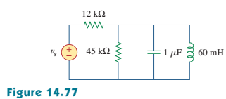

**14.34 A parallel RLC circuit is resonant at 5.6 MHz, has a *Q* of 80, and has a resistive branch of 40 *kΩ*.Determine the values of *L* and *C* in the other two branches.** (10’)

**14.42 For the circuits in Fig.14.81, find the resonant frequency *wo*, the quality factor *Q*, and the bandwidth *B*.** (10’)

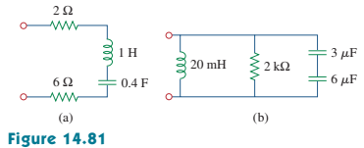

**14.46 For the network illustrated in Fig. 14.85, find**

**(a) the transfer function H(*w*) = Vo(*w*)/I(*w*),**

**(b) the magnitude of H at *wo* = 1 rad/s.** (10’)

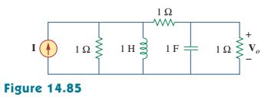

**14.56**

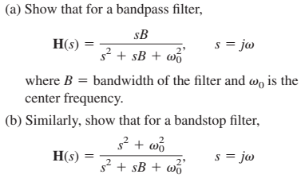(10’)

**14.57 Determine the center frequency and bandwidth of the bandpass filters in Fig.14.88.** (10’)

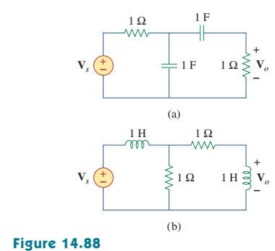

**14.59 Find the bandwidth and center frequency of the bandstop filter of Fig.14.89.**

(10’)

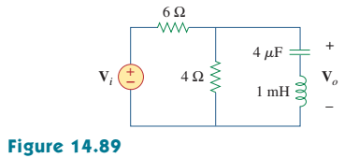

**14.61 Find the transfer function for each of the active filters in Fig.14.90.** (10’)

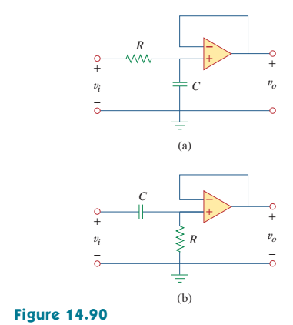

**14.66 A“general" first-order filter is shown in Fig.14.93.**

**(a) Show that the transfer function is**

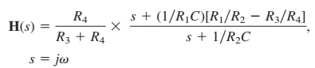

**(b) What condition must be satisfied for the circuit to operate as a highpass filter?**

**(c) What condition must be satisfied for the circuit to operate as a lowpass filter?** (10’)

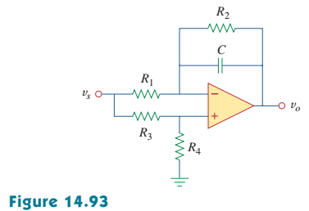

**14.77 A series *RLC* circuit has *R* = 100, *wo* = 40 rad/s, and *B* = 5 rad/s. Find *L* and *C* when the circuit is scaled:**

**(a) in magnitude by a factor of 600,**

**(b) in frequency by a factor of 1,000,**

**(c) in magnitude by a factor of 400 and in frequency by a factor of 105.** (10’)